PART A
(PART A: TO BE REFFERED BY STUDENTS) Experiment No.03

A.1—Aim:
To simulate simple peer-to-peer network, LAN and inter- LAN connections using Packet Tracer software

A.2--- Prerequisite:
Basic understanding of internetworking devices

A.3--- Outcome:
After successful completion of this experiment, students will be able to:
- Familiarity of the packet tracer software
- Identify the right devices and cables for building networks

A.4--- Tasks:

- Download and Install CISCO Packet Tracer Software: visit - netacad.com
- List down important components of the software
- List down the various features of the software
- Perform the following simulation activities:
- Simulate a peer-to-peer network
- Simulate a simple LAN connection
- Simulate a simple inter-LAN connection

Save the file and name it as CN_EXP4_your Roll no_Batch No.

(PART - B)

(TO BE COMPLETED BY STUDENTS)

(Students must submit the soft copy as per following segments within two hours of the practical.
The soft copy must be uploaded on the Blackboard or emailed to the concerned lab in charge faculties at the end of the practical in case there is no Black board access available)

Roll.No. : | Name:
Sem/Year : | Batch:
Date of Experiment : | Date of Submission:
Grade --

B.1: Procedure of performed experiment
(students are expected to write the reason of the choice of topology and device)

B.2: Observations and Learning’s:
(Students are expected to comment on the output obtained with clear observations and learning for each task/ sub part assigned)

B.3: Conclusion:
(Students must write the conclusion as per the attainment of individual outcome listed above and learning/observation noted in section B.2)

B.4: Questions of Curiosity:

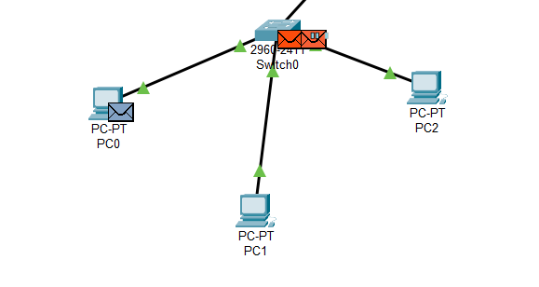

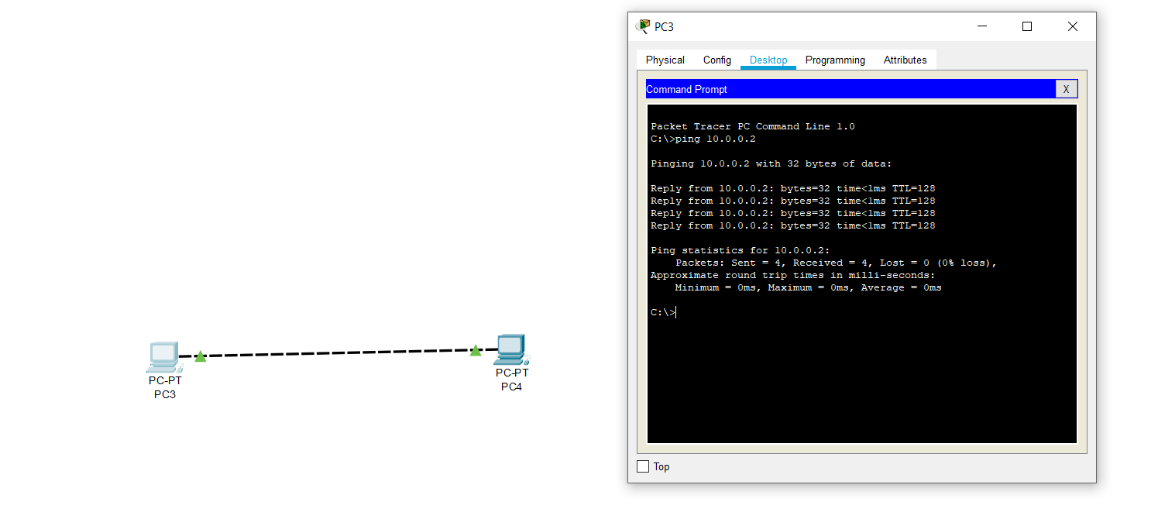
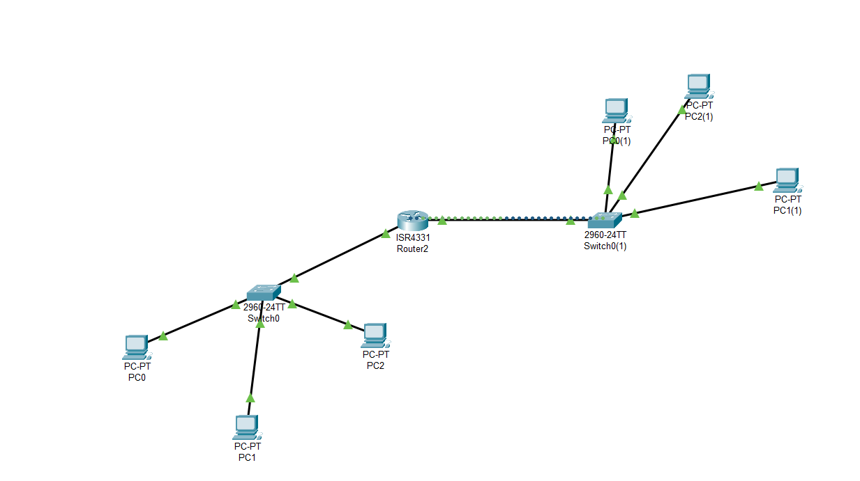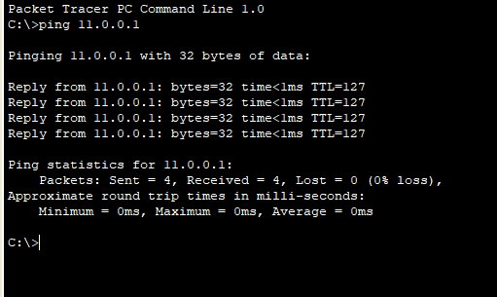
Q1. Difference between physical address and logical address? How to find physical address?

Q2. What is meant by interface on devices? List down the steps involved in configuring a router.

